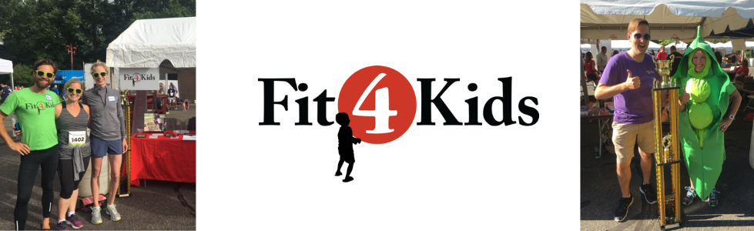
Sample Social Media and Communication

Hashtags: #makinghealthyfun #F4K #CorporateRun
Fit4Kids Social Media – Facebook, Instagram, Twitter – @GR_Fit4Kids
Anthem Corporate Run Facebook - @AnthemCorporateRun

Sample Tweet
Join <insert company handle> for RVA’s biggest office party - Anthem #CorporateRun - on 6/6 and make healthy fun by donating to charity partner @GR_fit4kids!

Sample Facebook Post
*Post with photo*
Get ready for RVA’s Biggest Office Party, the Anthem Corporate Run, and register for this year’s event on 6/6. Help make healthy fun for thousands of kids in our region by donating during registration to the event charity partner @GR_Fit4kids. Fit4Kids is a nonprofit dedicated to improving children’s health and wellness through physical activity and healthy eating.

Sample Instagram Post
*Post photo with trophy*
Win the Charity Cup Challenge trophy and make healthy fun by supporting charity partner @gr_fit4kids when registering for the Anthem Corporate Run! Join the fun at RVA’s Biggest Office Party on June 6th!
Hashtags: #makinghealthyfun #F4K #CorporateRun #BiggestOffice Party #happy #fun #running

Sample Email to Staff about Anthem Corporate Run
RVA’s Biggest Office Party, the Anthem Corporate Run, is back this year on Thursday, June 6th at 6pm (Innsbrook)! Thousands will gather their teams for this 5K event combining fun, health, and being social. <Insert Company Name> will participate this year and we invite you to join!

Charity Partner
As always, the Anthem Corporate Run is benefiting Greater Richmond Fit4Kids - a nonprofit dedicated to making healthy fun for children through healthy eating and physical activity programming impacting more than 10,000 kids each year. Learn more on their website - grfit4kids.org.

Registration
To register for this year’s event, use the link and code <enter code> to cover your entry fee. Since the race is on us, consider making a donation to Fit4Kids during the registration process and help us win the Charity Cup Challenge! The team with the highest donation average wins the Challenge and the coveted 4+ foot trophy for their office. Help make that happen and support kids’ health and wellness in the process!

Get event updates on the Anthem Corporate Run Facebook page!

