Richmond Schools celebrate Fruit and Veggie Week
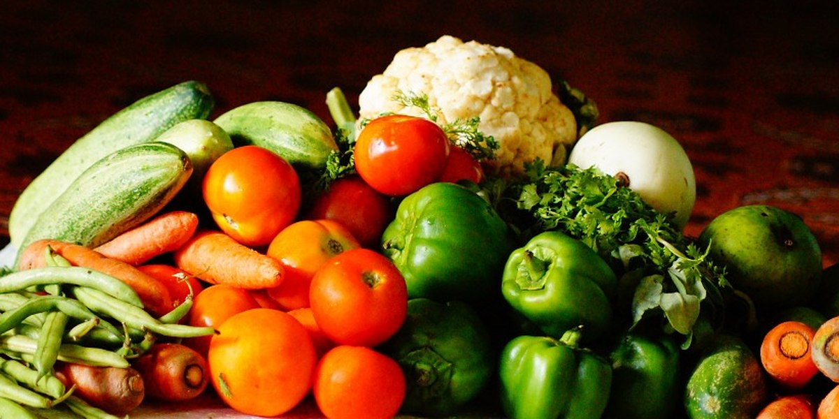

(Source: Pixabay) – NBC 12 On Your Side

March 24, 2019 at 7:10 AM EST - Updated March 24 at 7:10 AM
RICHMOND, VA (WWBT) - As part of National Nutrition Month, Greater Richmond Fit4Kids and Richmond City Public Schools are partnering up to celebrate Fruit and Veggie Week 20 different schools.

Students will be able to sample different types of vegetables and fruit each day at school March 25-29. More than 6,000 students will get to try items, such as red and green grapes, cauliflower, broccoli, spinach salad, and black bean and corn salsa.
“Fit4Kids and our partners are committed to dramatically increasing students’ fruit and vegetable consumption in order to improve their overall health and wellness,” said Fit4Kids CEO Mary Dunne Stewart in a release. “Fruit and Veggie Week is an opportunity to expose students to fruits and vegetables in a fun, educational way.”

More than 250 volunteers will be on site portioning and giving out the samples to students.

The program is funded by a grant from the Anthem Blue Cross and Blue Shield Foundation.

There will also be a celebratory event for Fruit and Veggie Week at Chimborazo Elementary School with Richmond Mayor Levar Stoney and other officials.

